OPERATIONAL GUIDE

Start the translation system

- Switch on the WIFI Router
  - Connect the power supply to the net
  - Press the power button on the WLAN AP; the light start to blink

- Attach the microphone to the raspberry pi’s microphone port
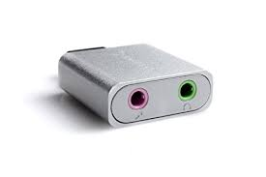
- Switch on the Raspberry pi attaching the power supply

Stop the translation
- Extract the usb audio from the Raspberry PI; this will start the Raspberry Pi’s shutdown procedure
- Remove the Raspberry Pi’s power supply
- Remove the WLAN AP’s power supply

Copy the service translation files
A new feature had been introduced.
When an usb-key is inserted in one free port the system will automatically copy the files to the usb-key removing afterwards the files on the raspberry-pi and shutdown the system.
In this way the system should autoclean itself.

